Document No.:

Project No.:

Author:

Release Date:

Revision:

Pages:

Copyright © Pteris Global Limited . All Rights Reserved.

Transmittal, reproduction, dissemination and/or editing of this document as well as utilization of its contents and communication thereof to others without express authorization are prohibited. Offenders will be held liable for payment of damages. All rights created by patent grant or registration of a utility model or design patent are reserved. In case the contractual agreement allows the customer to change the document such changes shall be clearly highlighted and shall name the person changing the document. In any case Pteris Global Limited is not liable for any amendments or changes by 3rd parties in the document and any possible consequences there from. Any changes made to an approved document, makes the document void, for the document to be valid it needs further review and approval by the relevant parties.

All trademarks and registered trademarks are the property of the respective owners. The use of registered names, trade names, description of goods etc. in this document, even if not specially identified as such, does not imply that such names may be regarded as free in the sense of legislation pertaining to registered trademarks and the protection of trademarks and may therefore be used by anyone.

Responsible for the contents

Pteris Global Limited

Singapore

**Revision**

| **Version** | **Release** | **Date** | **Init.** | **Description** |
| --- | --- | --- | --- | --- |
| 1 | 00 | 05-May-2010 | CHS | Initial version. |

Contents

Contents 4

Table of Figure 5

1. Preface 6

1.1 Document Objective 6

1.2 Scope 6

1.3 Audience 6

1.4 Document Limitations 6

1.5 Document Maintenance 6

2. Abbreviations and Acronyms 7

3. Overview 8

3.1 Manual Enconding Station Application 8

3.2 Baggage Scenarios 8

3.3 MES Functionalities Tasks 8

3.4 MES Functionalities Requirement with SAC 9

3.5 MES Functionalities Requirement without SAC 9

3.6 MES Event Logs 10

4. MES Functionality and Basic Screen Layout Schema 11

4.1 Windows Login 12

4.2 Title Bar 12

4.3 Logo and Status Area 13

4.4 Information Data and Entry Area 13

4.4.1 Multiple Information Data 16

4.5 Function Area 19

4.6 Status Bar Area 25

5. Document References 26

Table of Figure

**Figure 4‑1**: Basic Screen Layout Schema 11

**Figure 4‑2**: MESOWS Log-on Window 12

**Figure 4‑3**: Title Area 12

**Figure 4‑4**: Logo and Status Area 13

**Figure 4‑5**: Information Data and Entry Area 13

**Figure 4‑6**: Entry Area – Encode By Tag 14

**Figure 4‑7**: Entry Area – Encode By Flight 14

**Figure 4‑8**: Entry Area – Encode By Sort Destination 1 15

**Figure 4‑9**: Entry Area – Encode By Sort Destination 2 15

**Figure 4‑10**: Multiple Records – BSM 16

**Figure 4‑11**: Multiple Records – Airline and Flight Number 16

**Figure 4‑12**: Multiple Records – Flight Number 17

**Figure 4‑13**: Multiple Records – Sort Destination, Encode by Tag 18

**Figure 4‑14**: Multiple Records – Sort Destination, Encode by Flight 18

**Figure 4‑15**: Function Area 19

**Figure 4‑16**: Three Types of Operation Mode Shown In Status Area (Current Setting) 19

**Figure 4‑17**: Three Types of Encode Mode Shown In Current Setting of Status Area 20

**Figure 4‑18**: Three Types of Encode Mode Shown In Entry Area 20

**Figure 4‑19**: Entry Area for Key In Airline After RUSH Function Key Pressed 21

**Figure 4‑20**: Entry Area for Key In Airline After RUSH Function Key Pressed 21

**Figure 4‑21**: Flight List 21

**Figure 4‑22**: IATA Interline Print Tag 22

**Figure 4‑23**: IATA Interline Print Tag and Generation of Pseudo BSM 22

**Figure 4‑24**: IATA Fallback Tag Generation and Print 22

**Figure 4‑25**: In-House Tag Print and Generation of Pseudo BSM 23

**Figure 4‑26**: Pseudo BSM 23

**Figure 4‑27**: Filter Windows 24

**Figure 4‑28**: Tag Format 24

**Figure 4‑29**: Status bar Area 25

# Preface

## Document Objective

This document specifies the design of the Manual Encoding Station (MES) application, and it will be the main design document of further development work.

The customer’s approval of this detail design document is required before the development is started.

## Scope

The scope of this document is to describe the detail design of the MES based on the requirements stated in the tender document.

## Audience

This requirement specification is intended for decision-makers in the Chhatrapati Shivaji International Airport and Pteris Global Engineering Limited (PGL). This document will serves as the primary foundation for PGL developers to implement the MES application.

## Document Limitations

This document is limited to the design of the MES; no other system will be described.

## Document Maintenance

This document is the one of the PGL document management document suites and maintained by PGL.

# Abbreviations and Acronyms

|  |  |
| --- | --- |
| **Terms and Abbreviations** | **Description** |
| ATR | Automatic Tag Reader |
| BSI | Baggage System Interface. |
| BSM | Baggage Source Message. Refer to IATA RP 1745 |
| BHS | Baggage Handling System |
| CUTE | Common Use Terminal Equipment |
| DCS | Departure Control System. |
| FIS | Flight Information System. |
| IATA | International Air Transport Association |
| IP | Internet Protocol - Communication Protocol |
| LAN | Local Area Network |
| MES | Manual Encoding Station |
| MESOWS | Manual Encoding Station Operation Workstation |
| PGL | Pteris Global Limited |
| TCP/IP | Communication Protocol |
| SAC | Sortation Allocation Control |

# Overview

There are four Manual Encoding Station Operation Workstation (MESOWS) in Chhatrapati Shivaji International Airport BHS. These MESOWS are located at each of the Manual Encoding Station (MES). The MES software will be installed on the MESOWS. It is the main workstations for BHS operators to manual encode the baggage if BHS cannot handle them automatically.

## Manual Enconding Station Application

The MES application is an application component of Sortation Allocation Control (SAC) system. By using this application, BHS operator is able to manual encode the baggage with handheld scanner, touch screen, keyboard or mouse.

The standard graphic screen resolution of MESOWS will be 1024 x 768 pixels. The application can also be run under other higher resolution settings.

## Baggage Scenarios

Bags routed to Manual Encoding Station could have following scenarios:

* **Scenario 1** – No Tag.
* **Scenario 2** – Tag Unreadable by ATR. A Tag is present but scanner fails to read the Tag barcode.
* **Scenario 3** – No BSM. The BHS system cannot find any BSM to match with the baggage Tag number (IATA tag).
* **Scenario 4** – Late BSM. The BHS system cannot match any BSM with the baggage Tag number at the time the baggage sorted to MES. But the BHS system can find and match the BSM with baggage tag at the time the baggage encoded at MES.
* **Scenario 5** – Multiple BSM. The BHS system found more than one BSM matching with the Tag number.
* **Scenario 6** – Multiple Tags. There is more than one Tag attached on the baggage.
* **Scenario 7** – Lost Tracking. The baggage lost tracking when the time of BHS system making decision after the ATR and before decision point at Manual Encoding line.
* **Scenario 8** – Unknown Flight. There is no flight information found for the baggage.
* **Scenario 9** – No Allocation. There is no allocation found for the baggage.

## MES Functionalities Tasks

The functionalities tasks available at each Manual Encoding Station (MES) application as below:

* **Encode by Tag (License Plate)** – For the readable baggage tag (4 Digits Security Tag, 4 Digits Fallback Tag, IATA Fallback Tag, IATA Interline Tag and In-house Tag), operator can directly use handheld scanner to scan or key in the tag number from the baggage. The MES application will look for the destination for this tag number and if the destination can be found, this destination will use for encoding. Otherwise, the operator need to use others functionalities.
* **Encode by Flight** – When the system cannot be encoded by Tag, and the operator does know the airline and flight number, the operator can key in the airline and select the flight number or key in the flight number and select the airline. If nothing can be show in the selection either airline or flight number, the message will show in the message box as no flight number found for the airline key in or no airline for the flight number key in. This mean that this functionality will not able for encode and the operator need use others functionalities.
* **Encode by Destination** – If neither encode by Tag nor encode by Flight, the operator can use this functionality to encode the baggage. It will send the baggage to the encoded destination.
* **Encode by Problem Bag Destination** – If the operator unable to handle the baggage, this baggage will treat as problem bag. So the baggage will encode by Problem Bag Destination and send to Problem Bag Destination for further handling.
* **Encode by Rush Destination** – If the operator do know the baggage’s flight is in rush period, the operator can use this functionality for encode. If the system unable to find the rush destination as no allocation was done in the departure allocation, a message will show in the message box stated that no allocation can be found. Then the operator need to use others functionalities.
* **Remove Bag** – If the operator unable to use Encode by Rush Destination, the operator can use this functionality to manually remove the baggage and manually send to the destination.
* **Generate and Print Tag** – If the Tag label attached on the baggage damaged or cannot readable by the scanner, a new tag label can be printed and attached this new label to the baggage after removed the damaged or readable tag. Others than this, it is also can generate and printed for the Fallback tag and In-House tag.
* **Preview Active Flight List** – It can display all active flight (opened allocation and future allocation which the entire flight allocation was done in the Departure Allocation application) with it sort destination.

## MES Functionalities Requirement with SAC

When all connection is online to MES, all the functionalities listed in Chapter 3.4 will be applied.

The MES will periodically update and reconciled every 5 minutes for the sort allocation planning including the latest 10 minutes (configurable) received BSMs, active flight allocation, active function allocation, fallback mapping, airline allocation and related parameters which needed for MES to perform sortation without SAC. Once any change of the allocation, SAC will automatically update MES.

For the flight allocation, the data will only be kept in MES for -6 hours from the current time for those allocation already closed. This means that the flight allocation data will always keep last 6 hours closed flight allocation, all current opened flight allocation and future active flight allocation.

## MES Functionalities Requirement without SAC

If the only connection to the SAC is down between MES, the following functionalities will take effect as describe below:

* **Encode by Tag (License Plate) –** This Encode Mode limited to IATA Tag which included the latest 10 minutes (configurable) received BSMs and have downloaded Flight Allocation, Fallback Tag, Security Tag
* **Encode by Flight –** MES will able to processing the baggage by Flight and this Encode limited to the flight in downloaded flight allocation.
* **Encode by Destination** – MES will able to processing the baggage by Destination and this Encode will same as normal.
* **Encode by Problem Bag Destination** – MES will able to processing the baggage by Problem Bag Destination and this Encode will same as normal.
* **Encode by Rush Destination** – MES will able to processing the baggage by Rush Destination but limited to have downloaded Flight Allocation.
* **Remove Bag** – MES will able to processing the baggage by Remove Bag and this function will same as normal.
* **Generate and Print Tag** – MES will able to process the printing tag as normal except
  1. Print Tag and Generate Pseudo BSM for Tab named “IATA Interline”, this mean Pseudo IATA Interline BSM will unable to print without SAC.
  2. Printing In-House Tag for Tab named “In House” which needed to produce pseudo BSM and save into SAC database. This mean In-House Tag will unable to print without SAC.
  3. Only previous Pseudo BSM either IATA Interline or In House before SAC down, will able to view and printing Tags will disable when without SAC.
* **Reason (Status Area)** – MES will not show the reason why the baggage came to MES.
* **Preview Active Flight List** – Only the active flight allocation downloaded before SAC down will show in here.

## MES Event Logs

All the MES workstation will have record user’s specific actions and the resource or data affected by the operator action. Below are the lists of action which will record down:

1. System user login and logout
2. Encoded action including Encode by Tag, Flight, Destination, Problem Bag Destination, Rush Destination and Remove Bag.
3. Tag Printing
4. In-house BSM update and delete.

# MES Functionality and Basic Screen Layout Schema

The Manual Encoding Station (MES) screens adopt a layout scheme as shown below in the **Figure 4‑1**. It consists of Title Bar, Logo and Status Area, Information Data and Entry Area, Functions Area and Status Bar Area as illustrated and described in the Figure and table below.

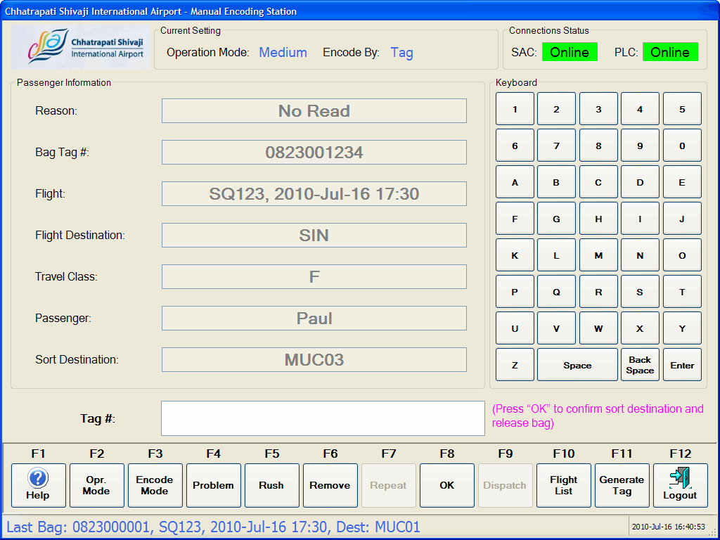

**Figure 4‑1**: Basic Screen Layout Schema

Here is the description of each section of the MES screen layout.

|  |  |
| --- | --- |
| **Screen Section** | **Description** |
| 1 | The **Title Bar** is the area to display the name of the airport and application name. |
| 2 | The **Logo and Status Area** contains Airport Logo, Current Setting, and System Connection Status. |
| 3 | The **Information Data and Entry Area** is the area to provide information for the encoded baggage, keyboard, data entry and instruction message. |
| 4 | The **Function Area** is the place to activate each function to perform each specify task. |
| 5 | The **Status Bar** contains Last Encoded Information and Current Time Stamp. |

## Windows Login

To login to the MESOWS, BHS operator needs to enter Domain user name and password in the standard windows logon screen.

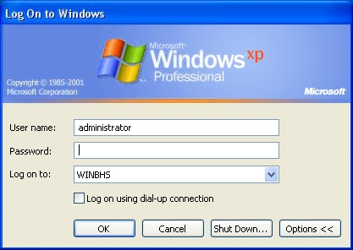

**Figure 4‑2**: MESOWS Log-on Window

Only the authorized users are able to access the functionalities MES application.

The creating and assigned user group will be done in Departure Allocation application. Please refer to BHS-503-09-1.00 SDS_Security document for details.

The MES workstation will initiate an automatically log off the workstation if after fifteen minutes (configurable) the operator has not logged off. This is to prevent log on from extending across operator shift changes.

## Title Bar



**Figure 4‑3**: Title Area

There are two parts in this Title Bar as below:

1. Airport name
2. Application name.

## Logo and Status Area



**Figure 4‑4**: Logo and Status Area

There are three sections in this Logo and Status Area as below:

1. **Airport Logo** – The place where the Chhatrapati Shivaji International Airport’s logo is located in the GUI.
2. **Current Setting** – The area to show the Operation Mode (Fast / Medium / Slow) and Encode By (Tag / Flight / Destination).
3. **Connection Status** – It is consist of all connection status to the MES workstation by using “Online” and “Offline” to indication the connection status. This application only is available when PLC connection status is in online.

## Information Data and Entry Area

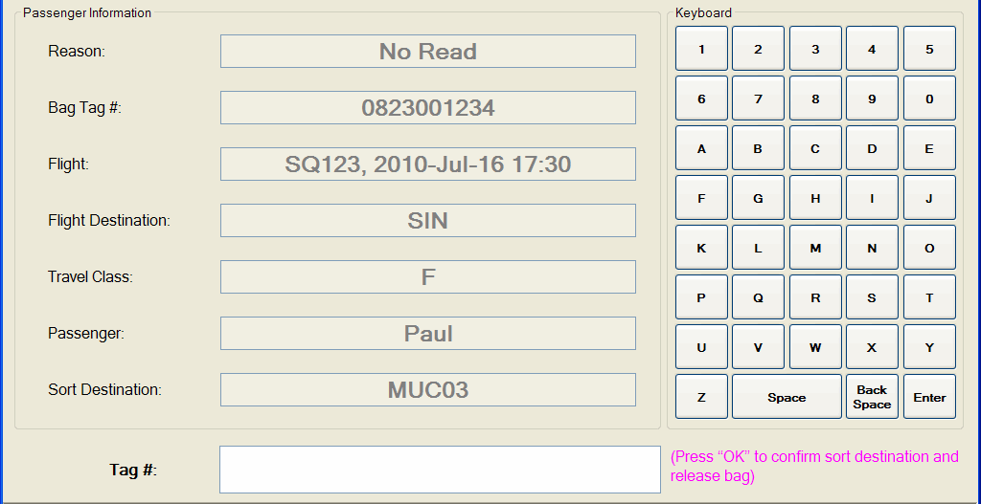

**Figure 4‑5**: Information Data and Entry Area

1. **Passenger Information** – This is the area to show all related passenger information for the encode bag. The information display as show in the **Figure 4‑5** **labelling 1**.
   1. **Reason** – Showing the reason why the baggage came to MES if known. Only showing when MES to SAC is connected. Possible reason will be as shown below:
      1. No Read – When ATR cannot read the Baggage Tag Number.
      2. No BSM – When BHS did not receive any BSM for the particular Baggage Tag Number.
      3. Late BSM – When the BSM coming late.
      4. Unknown Flight – When no flight found in BHS for this particular baggage.
      5. Multiple Baggage Tag – When multiple Baggage Tag detected by ATR.
      6. No Allocation – When BHS system cannot find any allocation for the baggage.
      7. Unknown Baggage – When the baggage lost tracking and become unknown baggage.
      8. Multiple BSM – When BHS system detected multiple BSM for this particular baggage.
   2. **Bag Tag #** – Showing the scanned or key in bag tag number if known, it can be either 4 digits Security Tag, 4 digits Fallback Tag, IATA Fallback Tag, IATA Interline Tag or In-house tag.
   3. **Flight** – Showing the Airline, Flight number and STD. (if known)
   4. **Flight Destination** – Showing the Flight destination. (if known)
   5. **Travel Class** – Showing the travel class for the passenger. (if known)
   6. **Passenger** – Showing the Passenger name. (if known)
   7. **Sort Destination** – Showing the sort destination after encoded. If this field is empty after encoded mean it cannot find sort destination for the encoded bag.
2. **Keyboard** – The soft keyboard for entry alphanumeric, clear and backspace for delete the character entered for the Entry as shown in the **Figure 4‑5** **labelling 2**. The keys will disable if it is not related to the encoded mode (Tag / Flight / Destination) and Rush function. If the keys needed to use then it will auto enable the keys.
3. **Entry Area** – The area to let user to scan or key in the Bag Tag number, Airline and Flight number, and sort destination as showing in the **Figure 4‑5** **labelling 3**. All the keyed in data must press keyboard “Enter” button to let the system to search the sort destination except for the tag number scanned by Handheld Scanner.



**Figure 4‑6**: Entry Area – Encode By Tag

When Encode Mode is Encode by Tag, the entry labelling will show “Tag #:” as showed in the **Figure 4‑6**.

The validation of the Tag Number of IATA Interline [RP1740a] and IATA Fallback Tag [RP1740b], In-house Tag will follow the rules below:

1. Direct key in 10 digits Tag Number.

The validation of the Tag Number of 4 digits Security Tag and 4 digits Fallback Tag will follow the rules below:

1. Direct key in 4 digits Tag Number.



**Figure 4‑7**: Entry Area – Encode By Flight

When Encode Mode is Encode by Flight, the entry labelling will show “Flight #:” as showed in the **Figure 4‑7**.

Flight data can be entered as either:

1. [2-3 char airline designator] + [space] + [1-4 digit flight number], e.g.: “SQ 123” or;
2. [2-3 char airline designator] + [space] + [1-4 digit flight number] + [space] + [0-1 char suffix], e.g.: “SQ 123 K” or;
3. [1-4 digit flight number] e.g.: “123” or;
4. [1-4 digit flight number] + [space] + [0-1 char suffix] e.g.: “123 K”.

The Flight Number search will follow rules as below:

1. All flights that are “numerical equal” to the entered flight number are included. If e.g. “1” is entered then flights with flight number “1”, “01”, “001” or “0001” is included.
2. Only production allocations with an open and/or close time within the time between –6 hours and +24 hours are included.



**Figure 4‑8**: Entry Area – Encode By Sort Destination 1



**Figure 4‑9**: Entry Area – Encode By Sort Destination 2

When Encode Mode is Encode by Flight, the entry labelling will show “Sort Dest.:” as showed in the **Figure 4‑8** or **Figure 4‑9**.

Sort Destinations are validated using the following rules:

1. Sort Destination data can be entered as (shown in **Figure 4‑8**) :

<last or last 2 digit destination number>

E.g. “3” -> “MUC02” or “02” -> “MUC02”

If less than 2 digits are entered the data is prefixed with “0” up to 2 digits.

1. The destination data can use the destination name like “MUC02” shown in **Figure 4‑9**.
2. **Instruction Message** – This is the placeto display the instruction message. The possible instruction message under the entry box as below:
   1. Enter Tag # – When it is in Tag Mode.
   2. Enter Flight # – When it is in Flight Mode.
   3. Enter Sort Destination – When it is in Destination Mode.
   4. Enter Airline – When RUSH function key pressed.
   5. Encoding successful – When the baggage was successfully encoded and released.
   6. Press “OK” to confirm destination and release bag – When operation mode is in “MEDIUM” and destination has been determined.
   7. Press “OK” to confirm destination – When operation mode is in “SLOW” and destination has been confirmed by operator.
   8. Press “OK” to confirm release bag – When operation mode is in “SLOW” and destination has been confirmed by operator.
   9. Unknown airline code – When operator enters invalid airline code.
   10. Unknown flight – When operator enters invalid flight number
   11. Enter alpha numeric only – When operator enters numeric characters in field only accepting alphanumeric characters.
   12. Enter numeric only – When operator enters alphanumeric characters in field only accepting numeric character.
   13. Encode using correct tag – When MES detected others than 4 digits and 10 digits tag number was encoded as it is in Encode by Tag.
   14. Release Pending – Displayed whenever another keyboard entry of information has been keyed in and the bag has not been released after a minute (configurable).

### Multiple Information Data

In any situation that the system found more than one records data to decide sort destination in the process of encoding, the system will pop-up a new window let user to select the data. Then system will based on the selected data to find the sort destination.

The possible data can be multiple records as below:

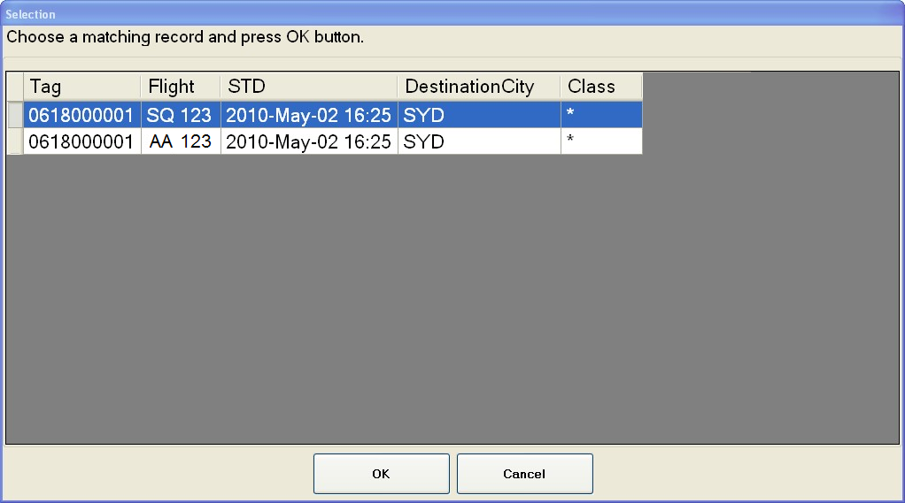

**Figure 4‑10**: Multiple Records – BSM

1. Multiple BSM – It has multiple BSM received in BHS.

When operator encodes by Tag and the system found multiple BSM records, it wills pop-up a window as showed in **Figure 4‑10**.

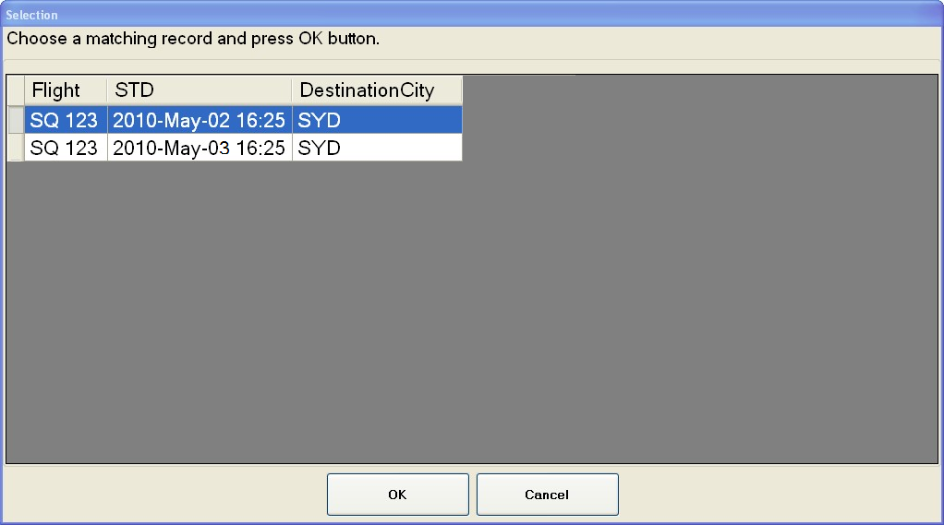

**Figure 4‑11**: Multiple Records – Airline and Flight Number

1. Multiple Airline and Flight Number – It has same Airline and Flight Number but with different STD.

When operator encodes by Tag or Flight and the system found multiple Airline and Flight Number records, it wills pop-up a window as showed in the **Figure 4‑10**.

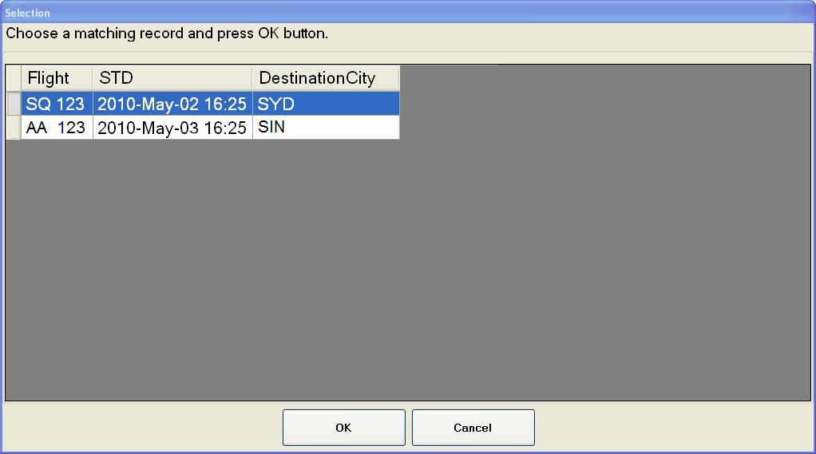

**Figure 4‑12**: Multiple Records – Flight Number

1. Multiple Flight Number – When Operator keyed in Flight Number only and system found multiple records with same Flight Number but different airline.

When operator encodes by Flight and the system found multiple Flight Number records, it wills pop-up a window as showed in **Figure 4‑12**.

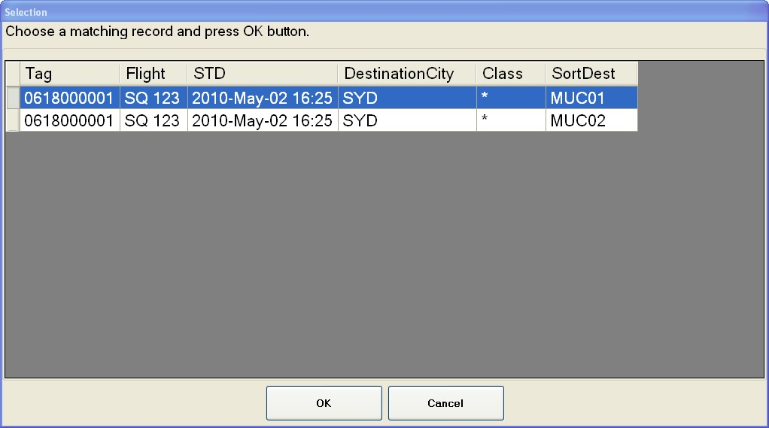

**Figure 4‑13**: Multiple Records – Sort Destination, Encode by Tag

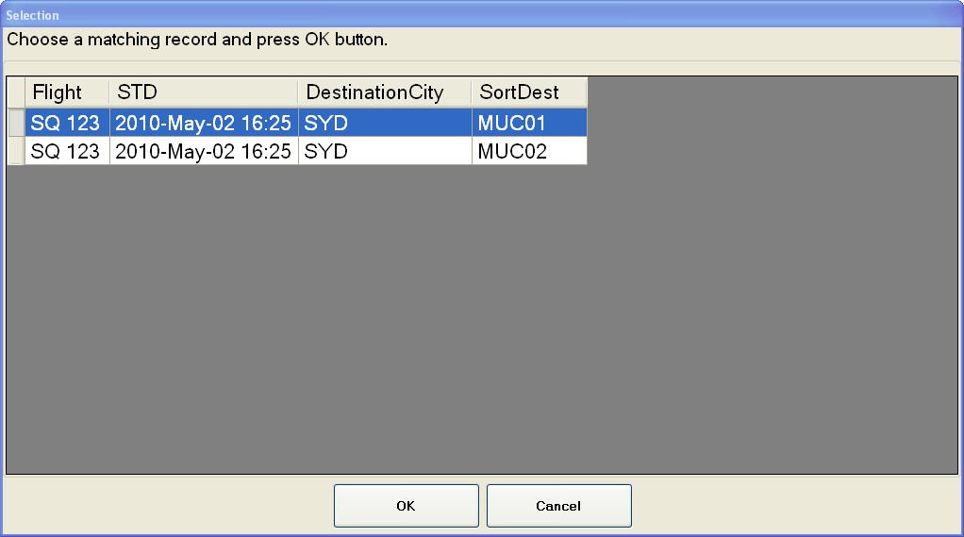

**Figure 4‑14**: Multiple Records – Sort Destination, Encode by Flight

1. Multiple Sort Destination – Based on the encoded data and found multiple destinations.

When operator encodes by Tag and the system found multiple Destination records, it wills pop-up a window as showed in **Figure 4‑13**.

When operator encodes by Flight and the system found multiple Destination records, it wills pop-up a window as showed in **Figure 4‑14**.

## Function Area

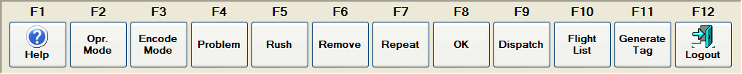

**Figure 4‑15**: Function Area

The Function Area consists as twelve function keys as below:

1. **(F1) Help**: A Help file is provided within the Manual Encoding Station and it can activate by clicking on the “Help” button or by “F1” function key. This file consists of the information regarding the usage of this MESOWS.

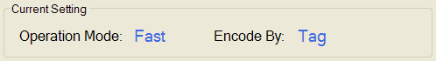

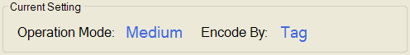

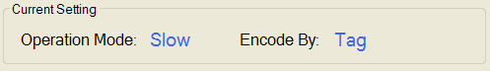

**Figure 4‑16**: Three Types of Operation Mode Shown In Status Area (Current Setting)

1. **(F2) Operation Mode**: Toggles between Fast, Medium or Slow mode to provide the ability for use different operation mode. When it is toggled to “Fast Mode”, the Status Area of Operation Mode also will show “Fast” as shown in **Figure 4‑16** **labeling 1**. It is same if toggled to “Medium” or “Slow” as shown in **Figure 4‑16** **labeling 2 and 3**.

When the MES is in the “Fast”, the baggage will immediately release after the baggage is successfully encoded.

When the MES is in the “Medium”, the baggage will release after the baggage is successfully encoded and the operator has pressed “OK” (F8) Function key to confirm.

When the MES is in the “Slow”, the baggage will release after the baggage is successfully encoded and the operator has pressed “OK” ” (F8) Function key to confirm, then following by pressed Function Key “Dispatch” (F9) to confirm to release the baggage.



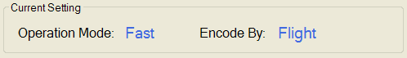

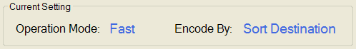

**Figure 4‑17**: Three Types of Encode Mode Shown In Current Setting of Status Area







**Figure 4‑18**: Three Types of Encode Mode Shown In Entry Area

1. **(F3) Encode Mode**: Toggles between Tag, Flight or Destination mode to provide the ability for use different encode mode. When it is toggled to “Encode by Tag”, the Current Setting “Encode By” of the Status Area is “Tag” as shown in **Figure 4‑17** **labeling 1** and the Entry Area as showed in **Figure 4‑18** **labeling 1** to allow operator to scan or key in the tag number. It is same if toggled to “Encode by Flight” as shown in **Figure 4‑17** **labeling 2 and Figure 4‑18** **labeling 2** to allow operator key in the airline and flight number. If it is toggled to “Encode by Sort Destination”, it will show as **Figure 4‑17** **labeling** 3 and **Figure 4‑18** **labeling 3** to allow operator to key in the sort destination.
2. **(F4) Problem**: The destination of the baggage is set as Problem Bag Destination for problem baggage handling.

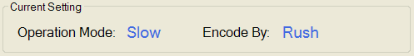

**Figure 4‑19**: Entry Area for Key In Airline After RUSH Function Key Pressed



**Figure 4‑20**: Entry Area for Key In Airline After RUSH Function Key Pressed

1. **(F5) Rush**: This function key will use to send baggage to Rush destination based on the airline. Once this function key pressed, the Current Setting for “Encode By:” will show “Rush” as showed in **Figure 4‑19** and the Entry Area will show as in **Figure 4‑20** to allow operator to enter the airline.
2. **(F6) Remove**: Remove or upload baggage from BHS system from MES.
3. **(F7) Repeat**: Allow operator to repeat send with last encoded data or destination. It is only apply for Encode by Flight, Encode by Destination, Encode by Problem and Encode by Rush.
4. **(F8)**: **OK**: The place to use for sort destination confirmation in Medium and Slow Operation Mode.
5. **(F9) Dispatch**: Dispatched the baggage from MES.

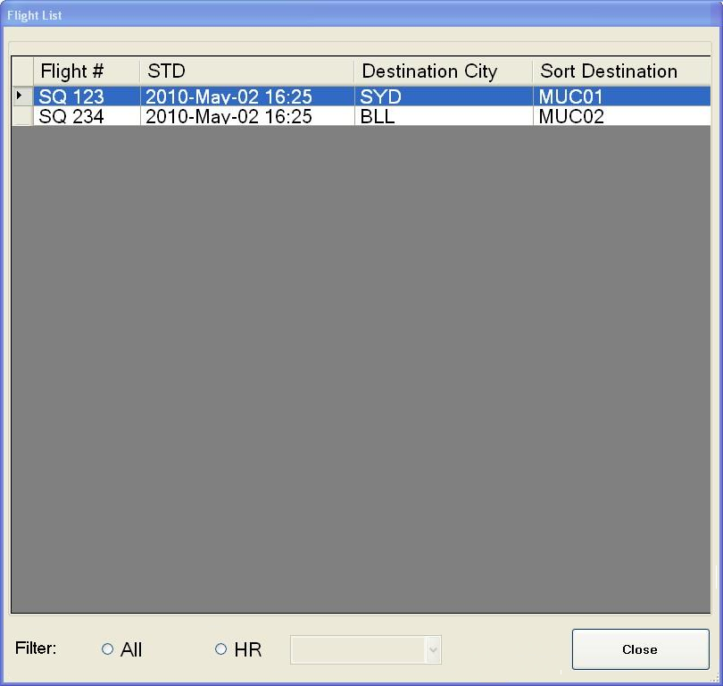

**Figure 4‑21**: Flight List

1. **(F10) Flight List**: It will pop-up new window to display all the active flight allocation. It is just read only table and operator can filter to show all records or last one hours to 9 hours.

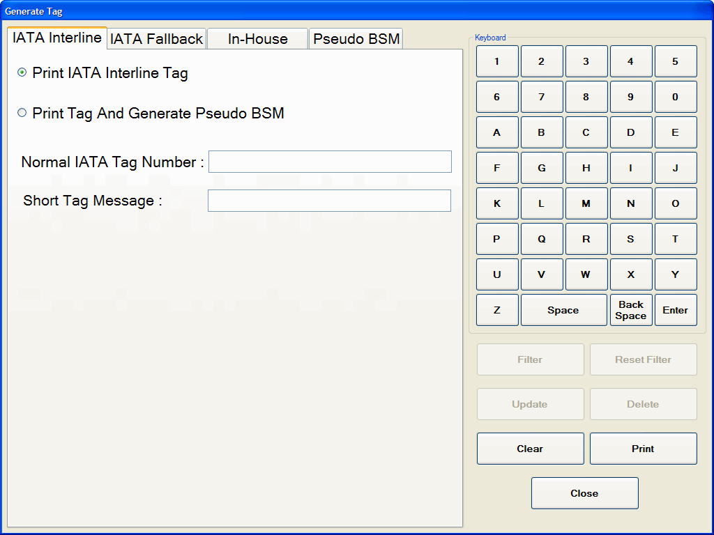

**Figure 4‑22**: IATA Interline Print Tag

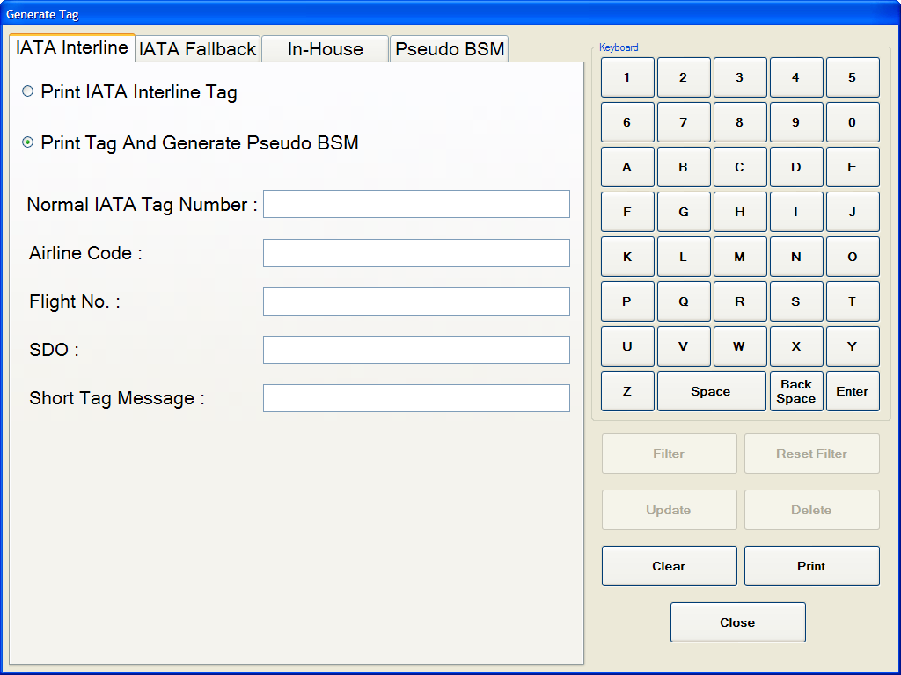

**Figure 4‑23**: IATA Interline Print Tag and Generation of Pseudo BSM

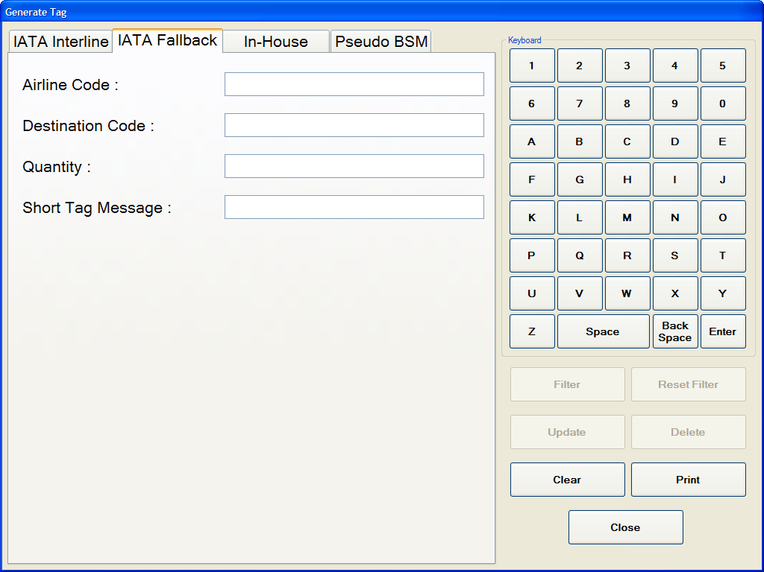

**Figure 4‑24**: IATA Fallback Tag Generation and Print

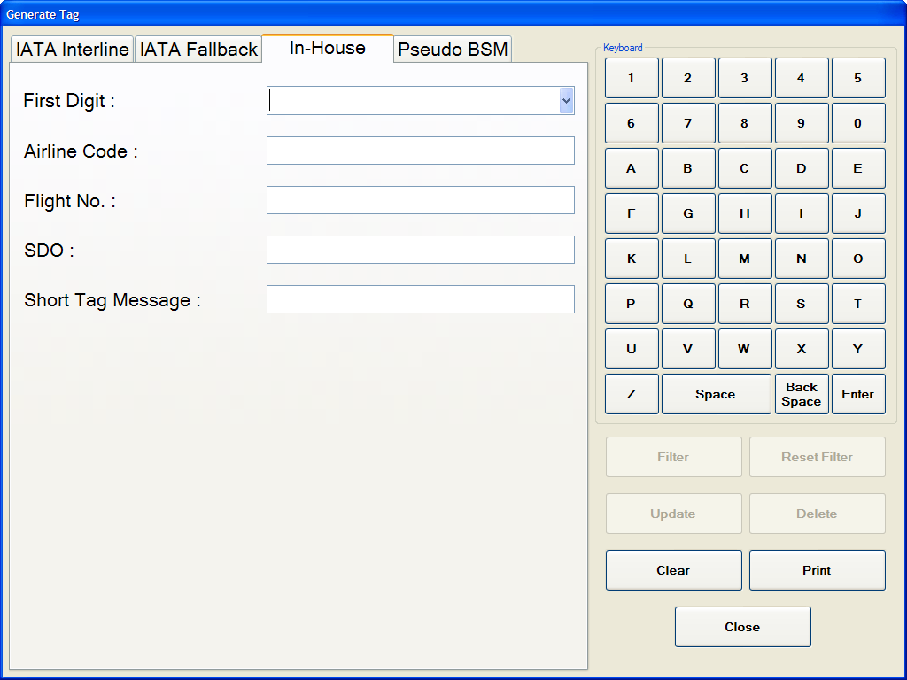

**Figure 4‑25**: In-House Tag Print and Generation of Pseudo BSM

1. **(F11) Generate Tag**: A label will be generated and printed. When the operator pressed on this function key, it will pop-up a new window as shown as in the **Figure 4‑22**. The operator can select one of three types (IATA Interline, IATA Fallback or In-house) of tag to generate and print as shown in the **Figure 4‑22** or **Figure 4‑23**, **Figure 4‑24**, and **Figure 4‑25**.

When the button “Print” pressed, and pop-up a confirmation box for double confirm. Once operator confirm, it will automatically print the tag and show a message in pop-up window for information of successful or unsuccessful printed (for all the 3 types) and successful or unsuccessful generated the pseudo BSM (only for IATA Interline if applied and In-house). These pseudo IATA Interline and In-house BSM will be created and send to SAC once the Tag successfully printed.

The operator is allowed to print IATA Interline Tag as showed in **Figure 4‑22**, or print IATA Interline Tag and generated pseudo BSM if the bag is No BSM as showed in **Figure 4‑23**.

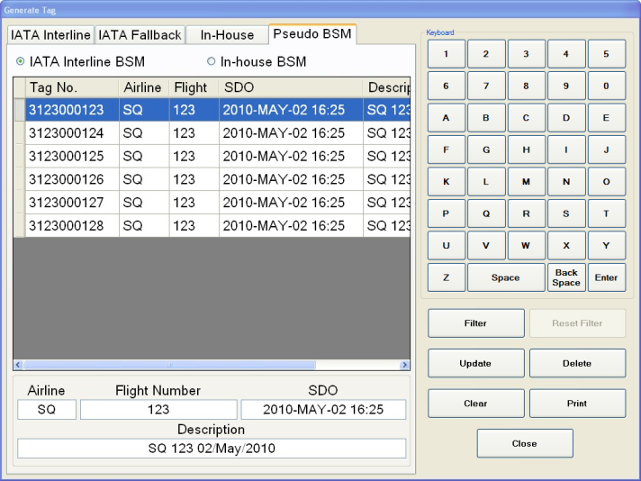

**Figure 4‑26**: Pseudo BSM

The IATA Interline and In-house pseudo BSMs will show in tab named “Pseudo BSM” in table list as showed in the **Figure 4‑26**. Operator can select radio button “IATA Interline BSM” or “In-house BSM” and the table will list out accordingly. The table for these two types pseudo BSM contains “Tag No.”, “Airline”, “Flight”, “SDO” and “Description”. Operator is allowed to update the Airline, Flight, SDO and Description, delete or print for each pseudo BSM by select on the each data row which wanted to change. The “Update”, “Delete” and “Print” button will enable as a row was selected. The text boxes below the tables will show the data as the selected row. If the operator wants to change the data, the operator can change the values of the text boxes. Once the updated, deleted or printed successful or unsuccessful done, it will pop-up a message box to inform the operator.

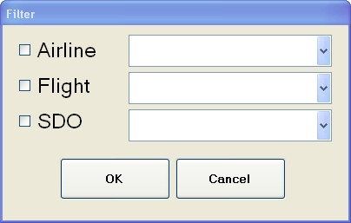

**Figure 4‑27**: Filter Windows

This Pseudo BSM table also allows filtering by click on the “Filter” button showed as in the **Figure 4‑26**. A new window wills pop-up as showed in the **Figure 4‑27** to allow filtering based on “Airline”, “Flight” or “SDO”. After the filtering done, the “Filter” button will disable and “Reset Filter” button will enable. As the “Reset Filter” button enabled, it means that the table now in filtering mode. If the “Reset” button enabled and “Reset Filter” disabled, it means that now the table not in filtering mode.

5.5 cm

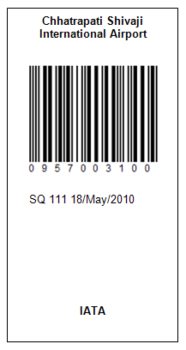

10cm

**Figure 4‑28**: Tag Format

Once the tag printed, it will look like showed in **Figure 4‑28** with the dimension 5.5cm x 10cm. The airport name will print at the top of the tag like showed in **Figure 4‑28** **labeling 1**. It will follow by barcode as in **Figure 4‑28** **labeling 2**. The **labeling 3** in **Figure 4‑28** is the place which the operator keyed short message when generating tag in “Enter Short Tag Message” box. The bottom of tag is the place to indicate the type of tag – IATA, Fallback or In-House as showed in **Figure 4‑28** **labeling 4**.

1. **(F12) Logout**: The MES application will shut down and log off the windows.

## Status Bar Area



**Figure 4‑29**: Status bar Area

This Status Bar Area consists of Last Bag Message **labeling 1** and Current Timestamp **labeling 2**.

# Document References

|  |  |
| --- | --- |
| **Abbreviation** | **Reference** |
| [Tender Specification] | Mumbai International Airport Pvt Ltd, Chhatrapati Shivaji International Airport, CSIA Expansion, Baggage Handling System, Ref: MIAL-HT-O-N55B-BG-DOC-004, Rev I |